Final Project Guideline for IT112 and IT113
1. General Instructions
- Students will be divided into 8 teams, each assigned to a different business field
- The project will be developed in two parts:
  - IT112 (Advanced Database Systems): Focuses on the business analysis and database design/implementation.
  - IT113 (Event-Driven Programming): Focuses on front-end development and applying event-driven programming concepts.
- Both parts are interconnected: the database designed in IT112 will be used for the web application in IT113.
- Final Requirements:
  - A written documentation (per requirements below).
  - A functional e-commerce site.
  - Group Presentation
- Note: Some team members may not be enrolled in IT112.
  - These students are only required to complete the IT113 components.
  - They should still support their group in IT112 tasks (e.g., documentation, presentation assistance), but they will not be graded for IT112 outputs.

2. Team Allocation
Teams will be shuffled and generated using an online random group generator tool. Each team will be assigned a specific business (please see below).
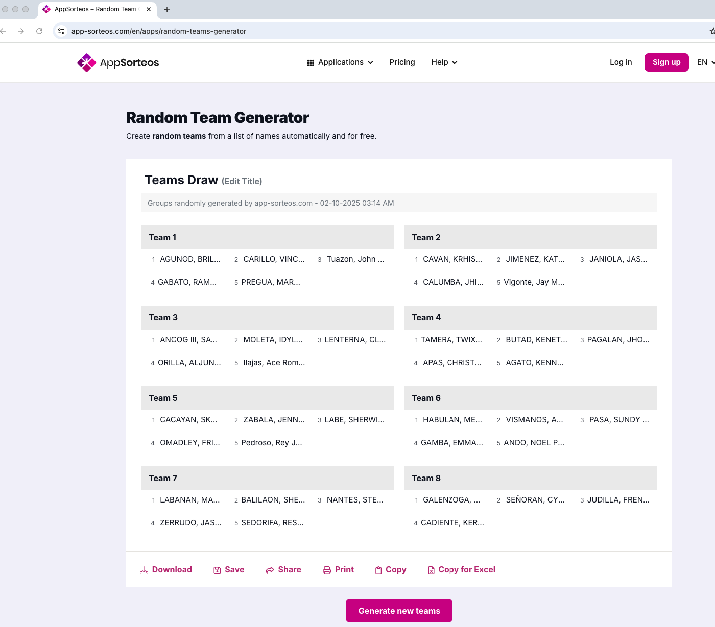
Team 1: Clothing and Apparel Shop – Online store for casual wear, office attire, and seasonal collections.
Team 2: Electronics & Gadgets Store – Selling phones, laptops, accessories, and small appliances.
Team 3: Bookstore & Stationery – Offering physical books, e-books, and school/office supplies.
Team 4: Pet Supplies Store – Food, toys, grooming kits, and accessories for pets.
Team 5: Home & Furniture Shop – Affordable furniture, décor, and household essentials.
Team 6: Sports & Fitness Store – Gym equipment, sportswear, supplements, and accessories.
Team 7: Beauty & Personal Care Store – Cosmetics, skincare products, and wellness items.
Team 8: Local Specialty Food Store – Selling local delicacies, snacks, beverages, or organic products.

3. Project Deliverables
ADS (IT112) Requirements
Each team will be required to provide a detailed report for the assigned business. The report should include:
- Problem statement or scenario: Describe a real-world problem or scenario within the assigned industry that requires an information management solution. Minimum of 3 paragraphs. 5 sentences = 1 paragraph.
- Logical Design
  - Requirements analysis: Based on the normalization, identify and define the key business objects and data entities relevant to solving the problem or addressing the scenario.
    - Minimum of 5 entities
    - Attributes: Minimum of 3 attributes per entity
    - Relationship & Cardinality: Minimum of 4 cardinalities
  - Data model: Create an ER diagram representing the relationships between the identified business objects/entities. Provide Chen and Crow Foot’s ER Diagram.
- Physical Design
  - Continuing from the logical design phase, translate the conceptual model into a physical database schema.
  - Provide SQL queries for:
    - Creating tables (DDL).
    - Inserting sample data into the tables.
    - Updating existing data.
    - Deleting data.
    - Selecting data using various criteria.
    - Joining tables to retrieve related information.
  - API Development
    - Build a simple REST API that connects to the database and returns data in JSON format.
    - API must include at least the following:
      - GET all records from a table (e.g., products, customers).
      - GET by ID (retrieve specific record).
      - POST (insert a new record).
      - PUT/PATCH (update an existing record).
      - DELETE (remove a record).
      - Provide sample code snippets

EDP (IT113) Requirements
- Develop an ecommerce website using Angular.
- Demonstrate event-driven logic (e.g., button clicks, cart updates, search queries, data validation).
- Consume the API built in IT112 for data retrieval and updates.
- Key Features
  - Minimum requirements:
    - Two user types: Business Owner and Customer (with login feature).
    - Basic Operations: Add to Cart, Update, Checkout, and Search.
    - Inventory & Sales Reporting (accessible by the Business Owner).
    - Exclusion: No online payment implementation.
- Objectives
  - Clearly define 4–5 SPECIFIC objectives of the project.
  - Objectives should go beyond “to create a website” or “to design a database.”
- Scope and Limitation
  - Scope:
    - Define the functionalities covered in the e-commerce site.
    - For example: managing product inventory, allowing customers to search and purchase, generating sales reports.
  - Limitations:
    - Clearly state constraints such as no online payment or like no voucher can be applied, limited number of business fields, or simplified checkout process.

5. Project Execution
Teams are expected to collaborate effectively and utilize research, critical thinking, and problem-solving skills to analyze the assigned business and design a database and system accordingly. Regular progress updates and consultations with the instructor will be implemented.
6. Submission, Schedule, and Evaluation
Submissions will be evaluated based on the clarity, thoroughness, creativity, and feasibility of the proposed ecommerce/database solution for the assigned business. The following are the schedule of checking and final submission. Use and refer to the SAMPLE TEMPLATE.
No. | Phase | Date | Mode of Validation | Graded
1 | Problem statement (I), Logical Design (II) and project proposal (IV) [check sample template for chapters] | Oct 24, 2025 | Email | As part of Midterm
2 | - Physical Design III (excluding API Development)  - Ecommerce (25%) | Nov 07, 2025 | Email, Video Demo (with captions/voice over) | Pre-Final
3 | Ecommerce (50%) | Nov 26, 2025 | Face-to-face | Final
4 | Ecommerce (75%) | Dec 10, 2025 | Face-to-face | Final
5 | FINAL PRESENTATION  - API Development (on docu)  - Ecommerce (100%) | Dec 17, 2025 | Face-to-face | Final

7. Final Presentation
Responsibilities:
Each team member is required to actively participate in the presentation. Responsibilities include presenting key aspects of the project, debugging any potential issues, and providing a comprehensive report. During the day of presentation, please provide two copies of your project documentation/report.
Attire:
In order to maintain a professional atmosphere, all team members are encouraged to wear formal attire during the project presentation. This will not only contribute to a polished and organized appearance but also reflects your commitment to the project and its importance.
Evaluation Criteria:
The projects will be evaluated based on the following criteria:
- Content & Understanding: Demonstration of a clear understanding of the project and its components.
- Functionality: The extent to which your project meets the specified requirements and performs its intended functions.
- Creativity: Originality and innovative solutions demonstrated in your project.
- Debugging
- Overall Presentation Quality: The clarity, organization, and effectiveness of your presentation. It is crucial that each team member is well-prepared to address questions and showcase your project's strengths during the evaluation.
Individual Rating:
- Formal Attire: Additional points will be awarded to a team member who wears formal attire during the presentation.
- Successful Code Tracing: Extra credit will be given to a team member who can successfully trace codes during the presentation.

